Project Design Phase-II Technical Architecture

|  |  |
| --- | --- |
| Date | 15 October 2022 |
| Team ID | PNT2022TMID02133 |
| Project Name | Project - Gas leakage monitoring and alerting system for industries |
| Maximum Marks | 4 Marks |

Technical Architecture

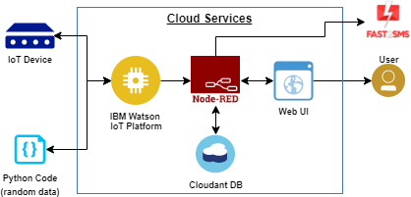

|  |  |  |  |
| --- | --- | --- | --- |
| **S.No** | **Characteristics** | **Description** | **Technology** |
| 1. | Open-Source Framework | Opensource frameworks for connecting to raspberry pi and node red | Working with Raspberry PI  Wiring Pi, Pigpio, Gpiozero, Rpi. GPIO |
| 2. | Scalable Architecture | Justify the scalability of architecture (3 – tier, Micro-services) | Data , models, operate at size, speed , consistency and complexity |
| 3. | Availability | The availability of application (e.g. use of load balancers, distributed servers etc.) | Numerous area leakage detection. |
| 4. | Performance | Design aspects for the performance of the application (number of requests per second, use sensors ) etc. | Full and effective detection using Raspberry pi for Industries. |

Table-1 : Components & Technologies:

|  |  |  |  |
| --- | --- | --- | --- |
| **S.No** | **Component** | **Description** | **Technology** |
| 1. | User Interface | Web UI or Website | HTML, CSS. |
| 2. | Application Logic-1 | Sensor initialization | Node RED |
| 3. | Leakage detector | To detect the leakage of gas in the industries in case of arrangement | Non-dispersive infrared sensors, or NDIR |
| 4. | Infrastructure (Server / Cloud) | Application deployed on cloud server | IBM Watson IoT Platform |

Table-2: Application Characteristics: